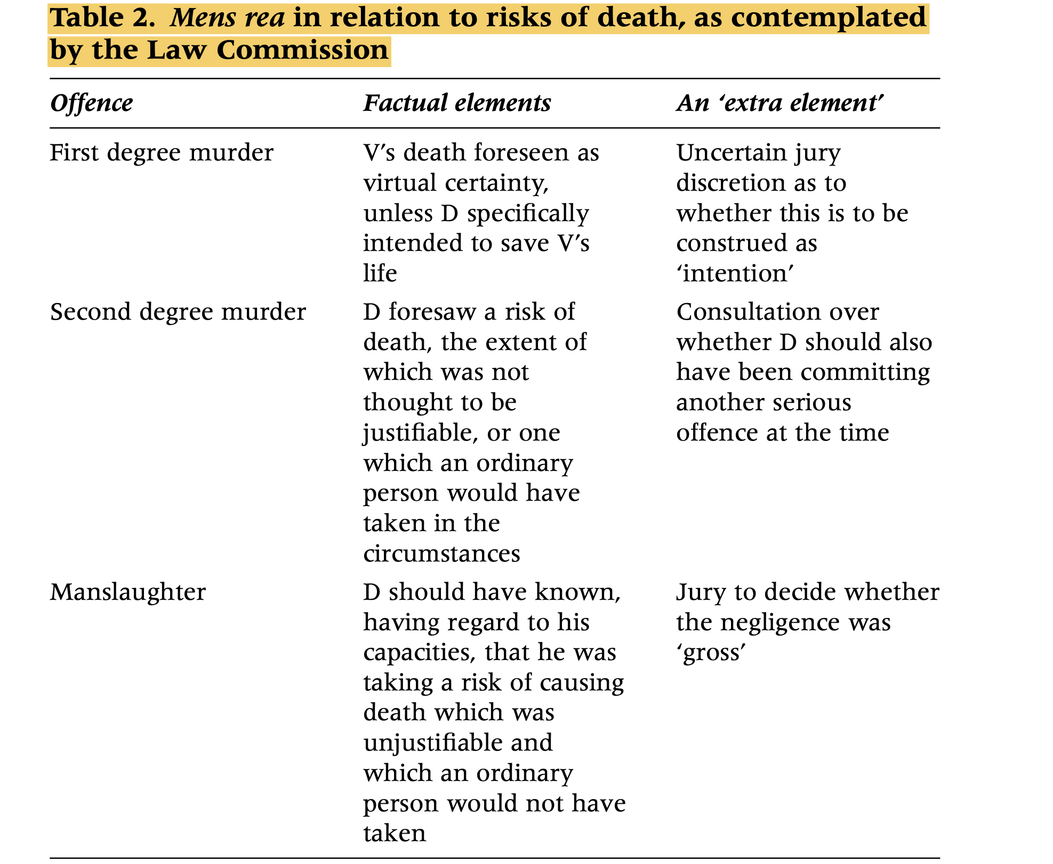

Introduction
- The article examines the Law Commission's recommendations for restructuring homicide offenses in England and Wales.
- It focuses on the move from two general offenses (murder and manslaughter) to three (first-degree murder, second-degree murder, and manslaughter).
- The article is critical but constructive, analyzing under-discussed issues like jury verdict complexities and the partial defense of consent in mercy killings.

Section 1: Restructuring Homicide Offenses

Key Changes Proposed by the Law Commission
- Three-Tiered Structure:
First-degree murder: Includes only cases where the defendant intended to kill. This offense carries a mandatory life sentence.
Second-degree murder: Covers cases where:
    - Intent to cause grievous bodily harm (GBH) is present.
    - Death results from reckless indifference to causing death.
Manslaughter: Restricted to cases of gross negligence or unlawful acts causing death.

Rationale Behind the Restructuring
- Fairer Labeling:
  - Current offenses (murder and manslaughter) are too broad.
  - Murder currently equates a paedophile killing to silence a victim with a person causing GBH unintentionally, which is unfair.
  - Manslaughter includes a wide range of cases, from minor negligence to severe recklessness.
- Mandatory Life Sentence for First-Degree Murder:
  - This applies only to intentional killings, recognizing the gravity of such actions.
- Flexible Sentencing for Second-Degree Murder:
  - Offers a spectrum of penalties to address varying levels of culpability.
  - E.g., a "reckless" killing might require a maximum sentence, while a GBH case might warrant a lesser sentence.

Cases and Legal References
- Intent in First-Degree Murder:
Cases like R v Walker and Hayles (1989) show juries can often find intent even in attempted murder cases, suggesting practicality in proving first-degree murder.
- Overlap Between Reckless Indifference and Intent to Cause GBH:
The Commission notes broad moral equivalence between reckless indifference to death and intent to cause GBH (Consultation Paper para. 3.172–3.174).
- Concerns About Overloading Second-Degree Murder:
Second-degree murder would absorb cases with a wide range of culpabilities, e.g., reckless atrocities vs. mitigated intentional killings like provocation or diminished responsibility.

Scholarly Opinions
- Jonathan Horder: Criticizes the current breadth of offenses and supports the narrower labels under the proposed restructuring (‘A Critique of the Correspondence Principle in Criminal Law’ [1995] Crim LR 759).
- M. Cavadino and P. Wiles: Highlight issues with varying seriousness within existing manslaughter offenses (‘Seriousness of Offences: The Perceptions of Practitioners’ [1994] Crim LR 489).

Practical Implications
- Jury Challenges:
Concerns over jurors struggling to agree on multiple potential verdicts (murder vs. manslaughter, first-degree vs. second-degree).
- Labelling Challenges:
Partial defenses like provocation and diminished responsibility would reduce first-degree murder to second-degree, adding complexity.

Section 2: Mercy Killing and Consent

The Proposed Partial Defense for Mercy Killings
- Key Proposal:
A partial defense for cases where:
    - The victim consents to death (e.g., terminally ill).
    - The defendant’s primary intent is to relieve suffering.
This would reduce liability from first-degree murder to second-degree murder.
- Proposed Safeguards:
The defendant must prove:
    - The victim was terminally ill and gave informed, voluntary consent.
    - The act was primarily motivated by relieving suffering (Consultation Paper paras. 8.68–8.83).

Cases and Examples
- R v Cocker (1989): Highlights cases where a mercy killer might not satisfy diminished responsibility but still deserves mitigation.
- Pretty v United Kingdom (2002): Confirms that criminalization of euthanasia aligns with Article 8 of the European Convention on Human Rights, but raises proportionality concerns regarding punishment.
- R v Kennedy (2005): Discusses causation challenges in mercy killing cases, emphasizing blurred lines between assisted suicide and murder.

Scholarly Opinions
- J. Horder:
Critiques existing provocation defenses and proposes gender-neutral concepts for mercy killings (‘Reshaping the Subjective Element in the Provocation Defence’ [2005] 25 OJLS 123).
- Jonathan Rogers:
Argues that mandatory life sentences for mercy killings are disproportionate and may violate human rights (‘Prosecutors, Courts and Conduct of the Accused which Engages a Qualified Convention Right’ (2005) Current Legal Problems 101).

Criticism of the Law Commission
- Failure to Address Mercy Killing Properly:
  - The Commission assumes most mercy killers will qualify for diminished responsibility, ignoring those who act out of pure compassion without mental abnormalities (R v Cocker criticism).
  - The Commission conflates complete defenses for euthanasia with partial defenses for family members, which is unjustified (Consultation Paper paras. 8.4–8.83).
- Practical Challenges:
  - The suggestion to restrict partial defenses to diminished responsibility excludes deserving cases, e.g., a spouse relieving suffering without mental impairment.

Human Rights Considerations
- Mandatory Sentences:
  - May violate Article 8 (right to privacy) or Article 3 (prohibition of inhuman treatment) in cases of proportionate punishment.
- Prosecutorial Discretion:
  - The reliance on discretion to mitigate charges is inappropriate for systematic issues.

Section 3: Reckless Indifference

Key Concept: Reckless Indifference
The Law Commission proposes that reckless indifference to death should form the basis for second-degree murder. This applies where:
  - The defendant perceives a risk of death but proceeds with their actions, displaying indifference to the outcome (Consultation Paper paras. 3.149–3.176).

Definition and Distinction
- Recklessness:
  - The defendant foresees a risk of death and consciously disregards it.
  - Examples of recklessness include actions driven by self-centered motives or the pursuit of trivial objectives (Consultation Paper paras. 3.150, 3.161).
- Distinction from Gross Negligence Manslaughter:
  - Reckless indifference requires foresight of risk, whereas gross negligence manslaughter applies where the defendant "should have" foreseen the risk but did not (Consultation Paper paras. 3.185–3.187).
  - R v G and R (2003): Reinforces the need for subjective foresight in recklessness.
- Shimmen Case:
  - Chief Constable of Avon and Somerset Constabulary v Shimmen (1987): The defendant underestimated the risk of breaking a window during a karate demonstration.
  - This was described as "reckless stupidity," demonstrating the line between reckless indifference and negligence (Consultation Paper para. 3.24).

Two Ladders of Culpability
The Commission highlights two "ladders" of culpability:
- Desired Outcomes:
Intention to kill → First-degree murder.
Intention to cause GBH → Second-degree murder.
Intention to cause lesser harm → Manslaughter.
- Undesired Outcomes:
Oblique intention (virtually certain death) → First-degree murder.
Reckless indifference (foresight of risk) → Second-degree murder.
Gross/ Unlawful negligence manslaughter → Manslaughter.

Scholarly Opinions
- Glanville Williams:
  - Distinguishes between "not caring less" and "not caring enough" in recklessness (‘The Unresolved Problem of Recklessness’ (1988) 8 Legal Studies 74).
  - Suggests that careless individuals may still exhibit reckless indifference.
- A. Norrie:
Discusses the subjective-objective interplay in recklessness, highlighting issues in legal definitions (‘Subjectivism, Objectivism and the Limits of Criminal Recklessness’ (1992) 12 OJLS 45).

Critiques
- Ambiguity in Indifference:
The Commission’s notion of "reckless indifference" is criticized for conflating everyday and justifiable risks (Consultation Paper paras. 3.22, 3.24).
Examples:
A driver who knowingly risks death for trivial reasons should be distinguished from someone who misjudges an ordinary risk.
- Need for Clarification:
Should courts or juries determine what constitutes an "everyday" or "justifiable" risk?
Suggestions:
Courts should assess whether a defendant's perceived risk aligns with societal norms.

Section 4: Jury Discretion and Verdicts

Practical Challenges
- Split Juries:
  - The Commission highlights the risk of juries failing to agree on partial defenses, leading to split verdicts.
  - Example: A jury might be divided between diminished responsibility and provocation as a mitigating factor, complicating sentencing (Consultation Paper paras. 2.53, 2.70–2.71).
- Jury Compromise:
  - When multiple partial defenses are presented, juries may reach compromise verdicts that do not fully reflect their reasoning.
  - R v Boreham (2001): Discusses the importance of jury unanimity on the factual basis of a verdict.

Scholarly Opinions
- D. Clarke:
Highlights practical issues with jury unanimity and recommends clear guidance on alternative charges (‘Jury Unanimity—A Practitioner’s Problem’ [2001] Crim LR 301).
- R. Taylor:
Explores jury discretion in homicide cases and suggests tighter procedural rules (‘Jury Unanimity in Homicide’ [2001] Crim LR 283).

Proposals for Improvement
- Limiting Verdict Options:
The Commission proposes restricting manslaughter to cases of gross negligence or reckless injury to simplify juror decisions.
- Recording Multiple Defenses:
Juries should record all agreed partial defenses (e.g., provocation and diminished responsibility) to assist judges in sentencing.

Critiques
- Inconsistent Approaches:
  - Jury discretion in gross negligence manslaughter allows for subjective judgments, which may lead to unequal outcomes.
  - The Commission retains undefined discretion in oblique intention and reckless murder cases, creating inconsistencies (Consultation Paper paras. 3.149–3.161).
- Reliance on Judges:
Judges may need to resolve factual disputes where juries cannot agree, leading to potential conflicts with jury findings.

